Agricultural Analysis

Vision
- Will promote private use of land for agricultural purposes
- Will have a thriving and sustainable equestrian community
- Will showcase personal ownership of horses, goats, and chickens
- Will cultivate horse businesses and extensive horse-friendly trails
- Will support ranchland and promote non-motorized recreational trails
- Will inspire rural character and lifestyle
- Encourage use of renewable energy
- Farmers’ markets at existing businesses
- Support stewardship of buffalo, llama, donkey, sheep, etc.(showcase personal ownership of horses, goats, and chickens)
- Promote sensible stewardship of livestock, as property can support
- Support stewardship of environment with strong agricultural practices (set an example for education, sustainability and resource management)
- Create manure industry connections
- Support new innovation in sustainable practices
- Enable more subsistence farming
- Farm stands collective for locals
- Coffee shop and bakery

Ranching and Grazing

During the early 20th century, San Marcos was comprised of many large ranches. In the 1950s, the Byrne Ranch lay East of HWY 14, while the Hughes (formerly Jarrett) Ranch and Calvin Ranch spread West and East of the road to the San Marcos Arroyo. The Thornton Ranch was and is still today East of the current San Marcos District. The Sweet Ranch lay North and South of the Santa Fe Railroad tracks extending to the Ortiz Grant. Today, the Bonanza Creek Ranch borders San Marcos to the North. Eaves Movie Ranch and Synergia Ranch are located in the northwest section of the District.
Though much of the large ranch land has been subdivided into smaller residential properties, the San Marcos area retains a ranching and grazing character. Today, large swaths of leased land, along with a few private properties, are used for grazing a diversity of livestock and many property owners keep pastures for horses. Regionally, this part of Santa Fe County is still used for grazing, according to the Santa Fe County Assessor’s Agriculture and Grazing Tax Benefits Overview and map. There are areas identified for grazing on state and federal lands within the San Marcos area.
The process for leasing public lands for grazing changes by agency. Bureau of Land Management (BLM) parcels in the area are leased in accordance with BLM grazing regulations found at 43 CFR Part 4100 and section 15 of the Taylor Grazing Act. The agency requires that a lessee own or lease a parcel of private land adjacent to the federal land. The BLM leases are issued on a 10-year basis with livestock numbers based on the carrying capacity of the grazing allotment. Grazing fees are based on the Animal Unit Month (AUM), or the estimated amount of forage needed to sustain one cow or its equivalent for a 1 month period. The fee formula was establish by Congress in the 1978 Public Rangelands Improvement Act and change annually depending on a number of factors including the beef cattle market. Prices have ranged from $1.35 to $2.11 per AUM over the past ten years. Half of the grazing fee collected goes back into a Range Improvement Fund, which can be spent on improvements to enhance management of the grazing operation. Improvements such as pasture fences, additional water sources or vegetation treatment (e.g. thinning) are provided upon request and are subject to available funding, the applicable Land Use Plan (2012 Taos Resource Management Plan), and site specific NEPA analysis.
The State Land Office (SLO), the other public lands available for leasing, awards leases in 5-year increments. Applicants are not necessarily required to have adjacent land or access to a lease in order to apply or bid on a lease. However, in a case where multiple applicants are seeking the same lease, access and adjacent land ownership will be taken into consideration when awarding the lease. Current lessees are notified during the June preceding the renewal of their lease and offered assistance in drafting a new contract before the property goes out for a bidding process (August 1 to September 1) to anyone else interested. Many families have had their lease for generations, but occasionally neighbors to the property or family related to the current lessee inquires with the SLO about bidding for the lease. The fee formula used by the SLO does not change, but it includes an adjustment factor that changes yearly based upon economic variables. Many of these variables are the same as those used to determine BLM fees.
Most SLO carrying capacities were determined and set in the 80’s and have not changed. However, if a lessee believes their carrying capacity needs to be changed to better reflect current conditions, they may fill out a request form for a carrying capacity reevaluation. Then, a resource manager will conduct a field assessment of the lease and make recommendations on whether or not the carrying capacity should change. These site visits also serve the purpose of gathering data on overgrazing and to provide guidance on management plans. If individuals wish to improve the leased property, the National Resources Conservation Services (NRCS) is available to apply for assistance. All improvements on state land (fences, brushwork, water developments… etc.) require the submission of an improvement application prior to the work being done. Lessees often partner or cost share with NRCS to complete the work, but many fund and implement the improvements on their own.

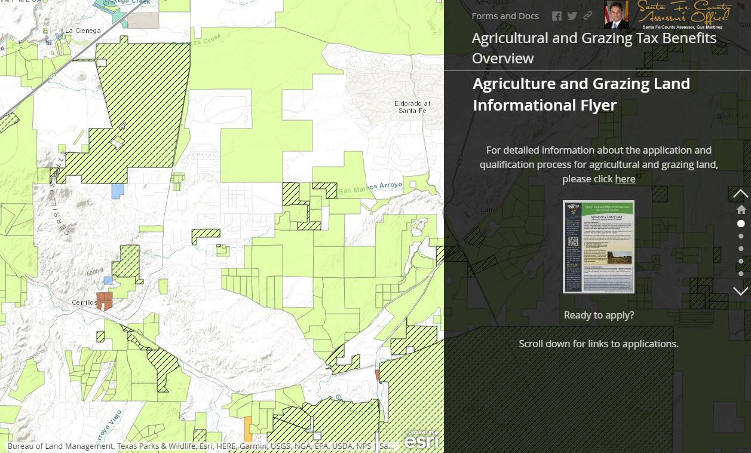
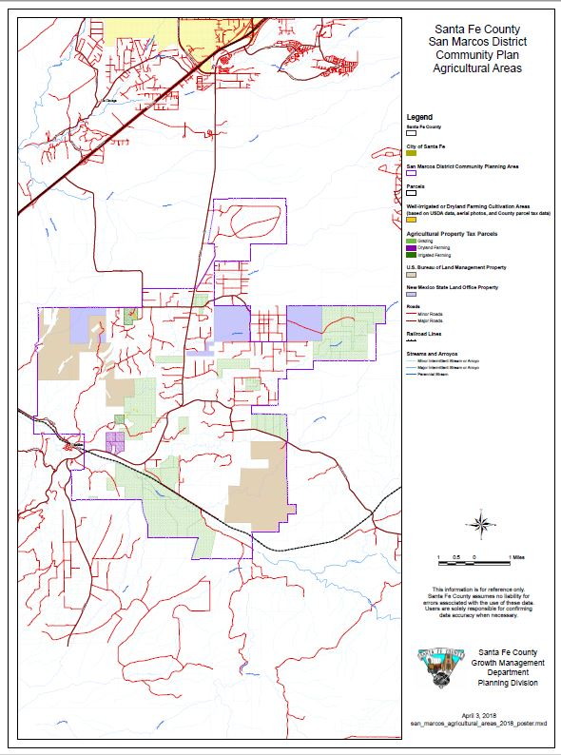

Equestrian

San Marcos prides itself on its horse culture. Many residents own horses and many horse-based businesses locate themselves in this District because of the history and prevalence of equestrian uses. San Marcos considers itself a supportive, responsible, community-minded horse environment. Many people have horses for their own personal use. Horse-based businesses are also a large part of the local economy.

There are many businesses and services supporting the regional equestrian community, such as:
- Horses For Heroes, a New Mexico-based 501(c) 3, is a “unique horsemanship, wellness and skill-set restructuring program” which is free to all post 9/11 veterans and active military personnel, especially those who have sustained PTSD, physical injuries, or have experienced combat trauma during their service.
- Thal Equine LLC, a regional full-service horse hospital, hosts a facility for intensive care, elective and emergency surgery including colic surgery, long-term hospital care and monitoring, as well as reproductive services.
- Various equine therapy services can also be found in the District, including Equine Experiential Education (E3A) and Equine Assisted Growth and Learning Association.
- The Horse Shelter sits at the southern boundary of the District and provides needed services for the region’s abused and neglected horses.
- There are also horse facilities, supply stores, and services such as Beth Longanecker’s Training Stable, the San Marcos Feed Store, Mortenson Silver & Saddles, and farriers (horseshoers) that support and make their living in the District.

Manure

With all of the equestrian activity in the area, the by-product, manure, is readily available. The San Marcos District supplies manure for agricultural purposes all around the Santa Fe region.

Agriculture

San Marcos District has less irrigated agriculture than most other parts of Santa Fe County. Synergia Ranch, a private ranch managed as a “Center for Innovation & Retreats,” hosts an organic orchard and sites for innovative agriculture. There are also two commercial nursery and greenhouse operations in the District, Plants of the Southwest and New Mexico Plan Company. Private landowners use greenhouses to grow small-scale crops. San Marcos area does not have the acequia infrastructure that exists in the northern part of Santa Fe County and thus more of the agricultural activity in this area is dry-land agriculture and ranching. Currently, there are 162 acres of privately owned farms that do not use irrigation (“dryland farming”) and 152.61 acres of irrigated farming in San Marcos District.

Key Issues

- Limitations placed on equine, goat, chicken, horse and agricultural use
- Obstacles to equestrian business and lifestyles
- Limitations on livestock and agricultural use
- Unknown information on current numbers of horses people use personally

Connecting Actions as applicable to Goals A, B and C
- Determine appropriate usage
- Determine appropriately scaled uses
- Investigate the current typical size of equestrian business (in relation to acreage)
- Review small-business – equine
- Community access – easement for trails
- Connect with Community College and other training resources
- Implement innovative technology
- Adopt innovative economic practices
- Share new best practices
- Create flexible, dynamic regulations to incorporate new technologies
- Coordinate with real estate agents and developers to align vision
- Post public information on websites
- Create community ambassadors program to maintain stewardship

Visions that inform Goal A:
- Will have a thriving and sustainable equestrian community
- Will showcase personal ownership of horses, goats, and chickens
- Will cultivate horse businesses and extensive horse-friendly trails
- Will inspire rural character and lifestyle
- Support stewardship of environment with strong agricultural practices (set an example for education, sustainability and resource management)
- Create manure industry connections
- Support new innovation in sustainable practices

Goal A Horse community: Support a healthy equestrian community, enabling a rural lifestyle and stewardship of the land and animals.

Committee Discussion 9.26.18
- Determine appropriate:
  - Size/scale
  - Intensity
  - Commercial/private
  - Equitable
  - Caring for land, sensible stewardship
  - Waste management
  - Viability
- Action:
  - Review code options
  - Diversity of businesses related to use
  - Trail access
  - Innovative technology and economic uses
  - Flexible regulations
  - Information sharing- website and other (groups)
  - Community stewards

Visions that inform Goal B:
- Will promote private use of land for agricultural purposes
- Will support ranchland and promote non-motorized recreational trails
- Will inspire rural character and lifestyle
- Support stewardship of buffalo, llama, donkey, sheep, etc.(showcase personal ownership of horses, goats, and chickens)
- Promote sensible stewardship of livestock, as property can support
- Support stewardship of environment with strong agricultural practices (set an example for education, sustainability and resource management)

- Enable more subsistence farming
- Farm stands collective for locals
- Support new innovation in sustainable practices

Goal B Agricultural community: Promote continues use of land for agricultural purposes and agricultural lifestyle, creating cultural and economic connections to support sustainably practiced agriculture.

Committee Discussion 9.26.18
- Determine appropriate:
  - Size/scale
  - Intensity
  - Commercial/private
  - Equitable
  - Caring for land, sensible stewardship
  - Waste management
  - Viability
- Action:
  - Review code options
  - Community College connection
  - Stewardship
  - Innovative technology and economic uses
  - Flexible regulations
  - Information sharing- website and other (groups)

Visions that inform Goal C:
- Farmers’ markets at existing businesses
- Create manure industry connections
- Support stewardship of environment with strong agricultural practices (set an example for education, sustainability and resource management)
- Create manure industry connections
- Enable more subsistence farming
- Farm stands collective for locals
- Encourage use of renewable energy
- Support new innovation in sustainable practices

Goal C Horse and agriculture business: Support stewardship of the environment through farming and ranching businesses that enable the continued rural lifestyle and character of the District.

Committee Discussion 9.26.18
- Determine appropriate:
  - Size/scale
  - Intensity
  - Impact
  - Commercial/private
  - Equitable
  - Caring for land, sensible stewardship
  - Waste management
  - Viability
- Action:
  - Review code options
  - Trail connection
  - Community College connection
  - Stewardship
  - Innovative technology and economic uses
  - Flexible regulations
  - Information sharing- website and other (groups)

2006 San Marcos Community Plan p. 12-13
https://arcg.is/1WuDT0 http://www.nmstatelands.org/uploads/files/Fee%20Schedules/BLM_Slo%20Comparisons_final%202016.pdf
Discussion with Lucille Martinez, Agriculture Leasing Manager SLO, on May 1, 2018 and email with Megan Boatright, Rangeland Ecologist with NMSLO on May 7, 2018.
https://www.horsesforheroes.org/ - reword this direct quote
http://thalequine.com/ - direct quote
https://reflectreinvent.com/about-us-2/machel-jordan/
https://synergiaranch.com/
Based on USDA Cropland data and Santa Fe County aerial imagery

